**ONLINE STORE:**

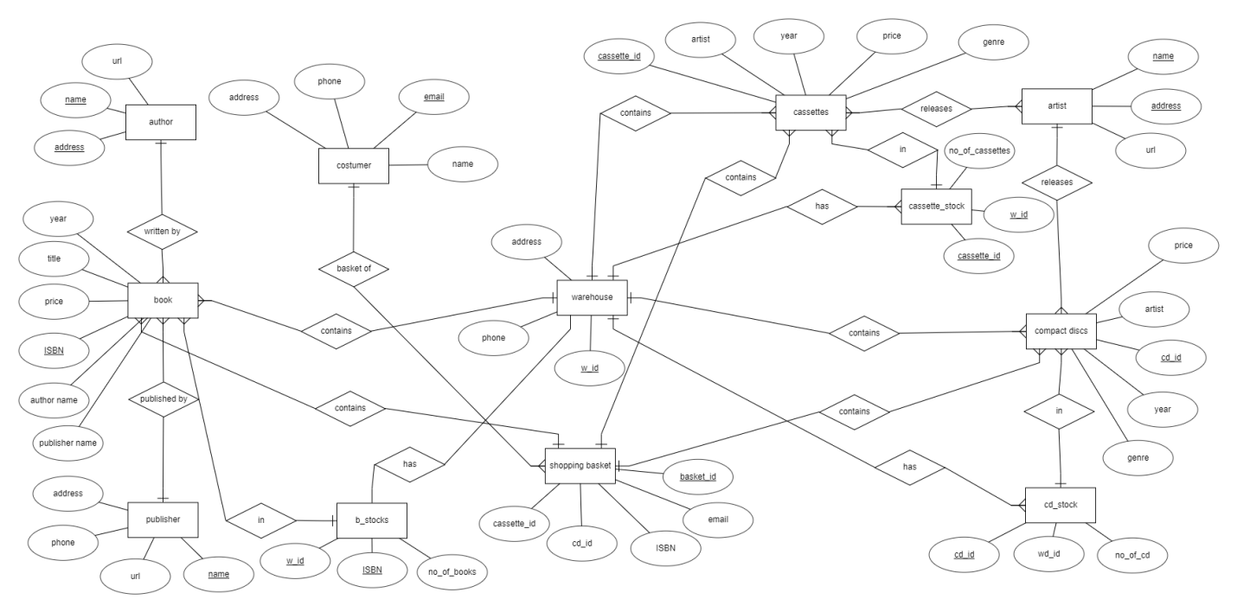

From this ER Diagram we can infer that online store for purchasing books , cassettes and compact discs.